Lab # 2. Understand Algorithm Development by
Implementing Piece-Wise Functions
Objectives Achieved
- Developed algorithms for computational problems using the 4-step process
- Learned basic input-output in C using printf() and scanf() functions
- Implemented conditional execution using if/else statements
- Created programs for piecewise functions.
Software Tools Used
- Code: Blocks IDE with MinGW Compiler
- Windows Operating System
Task 1: Algorithm Development
Problem Description
Develop a general algorithm to generate a pattern of squares for any input N using the 4-step algorithm development process.

Step 1: Work on Example
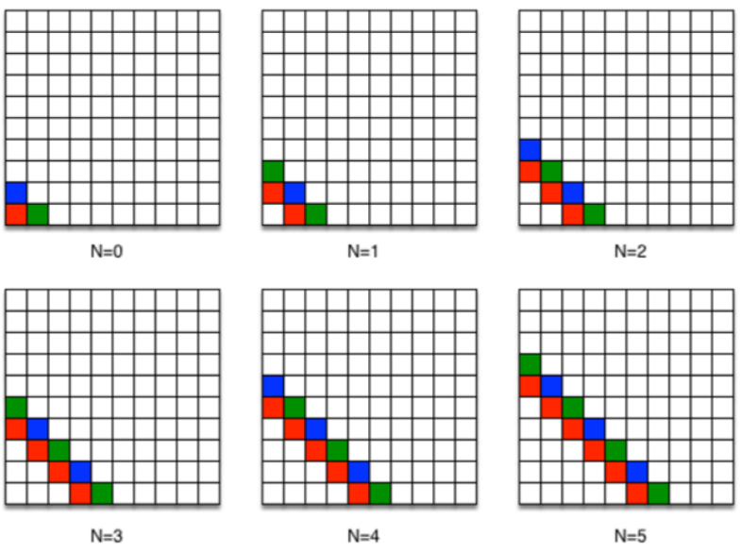
For small values:
- N = 0 → empty or minimal grid
- N = 1 → 1×1 square
- N = 2 → 2×2 square
- N = 3 → 3×3 square
We observe:
- Pattern forms a square grid
- Size depends directly on N

Step 2: Write Steps
- Take input N
- Create rows from 1 to N
- For each row, create columns from 1 to N
- Print required symbol (e.g., * or number) in each column
- Move to next line after each row

Step 3: Generalization
- Outer loop → controls rows (1 → N)
- Inner loop → controls columns (1 → N)
- Pattern is generated using nested repetition

Step 4: Testing
Test for:
- N = 1 → correct
- N = 3 → square pattern visible
- N = 5 → larger correct pattern

Final Algorithm
- Start
- Input N
- For i = 1 to N
For j = 1 to N
Print *
Move to next line
- End

Conclusion (Task 1)
This task helped in understanding how problems are analyzed step-by-step before coding. The 4-step method improves clarity and ensures the algorithm works for all inputs. It also introduced the concept of nested logic for pattern generation.

Task 2: Implementation in C
Problem Statement
Implement the function:
$$f(n)=\left\{\begin{matrix}-n-4 & n<3 \\ n^{2}-7 & 3≤n≤10 \\ \frac{120}{n}+n & n>10\end{matrix}\right.$$

Logic Explanation
- Program takes integer input n
- Uses if-else conditions to check ranges
- Executes corresponding formula
- Displays result

Algorithm
- Start
- Input n
- If n < 3 → f = -n - 4
- Else if 3 ≤ n ≤ 10 → f = n² - 7
- Else → f = (120 / n) + n
- Display result
- End
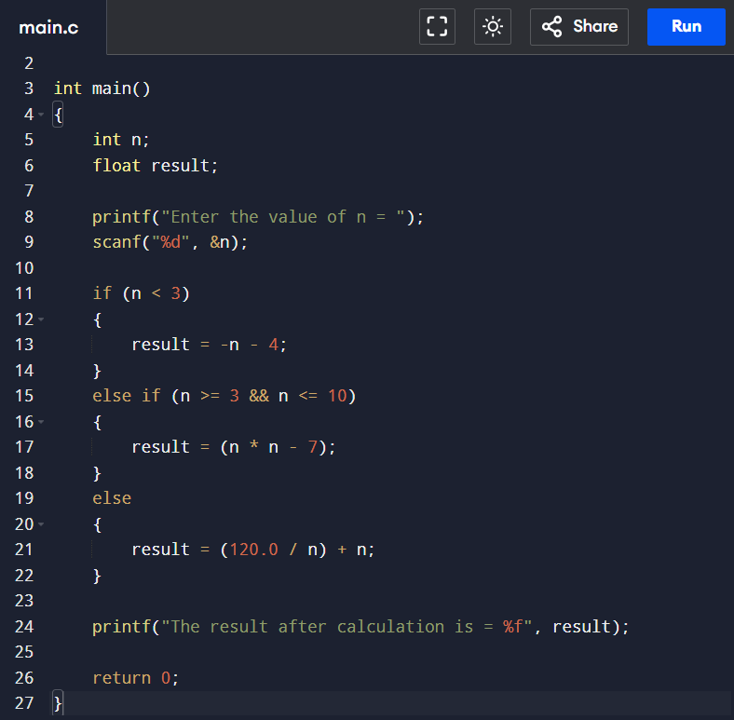
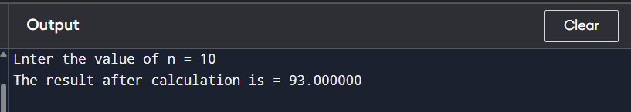
C Progarm

Conclusion (Task 2)
This task demonstrated how mathematical functions are implemented using conditional statements. It improved understanding of decision-making in programming and highlighted the importance of correct condition ranges.

Post-Lab Task: Even or Odd Program

Problem Statement
Write a C program that takes an integer input from the user and determines whether the number is even or odd.

Algorithm
- Start
- Input an integer number n
- If n % 2 == 0
Display "Number is Even"
- Else
Display "Number is Odd"
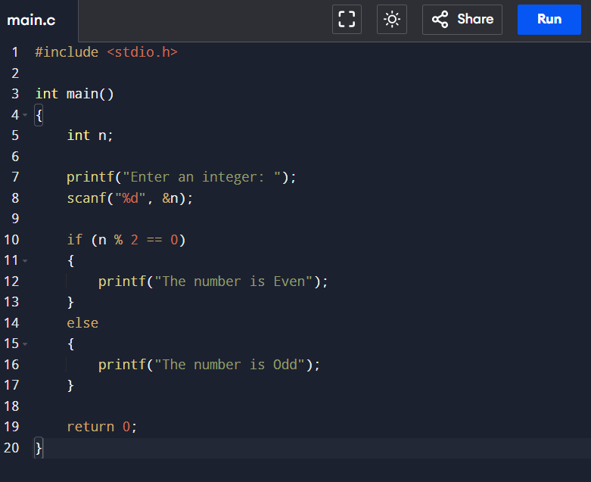
- End
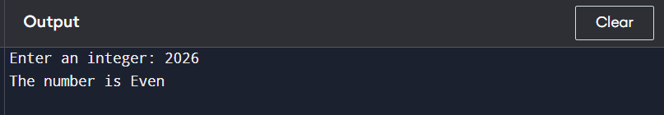

Conclusion

This task demonstrates the use of the modulus operator % and conditional statements to classify numbers. It strengthens understanding of basic decision-making in programming

Critical Analysis (Tasks 1, 2 & Post-Lab)

This lab effectively developed fundamental programming skills by combining algorithm design, implementation, and testing. Task 1 improved logical thinking by translating conditions into structured if-else statements, though minor syntax and condition errors can easily affect results. Task 2 emphasized the importance of proper testing using diverse inputs to ensure correctness across all cases, highlighting that incomplete testing may leave logical flaws undetected. The post-lab task reinforced basic concepts like the modulus operator and simple decision-making, strengthening core understanding but with limited complexity. Overall, the lab enhanced problem-solving, debugging, and coding accuracy, while showing that consistent practice is necessary to avoid common mistakes.

